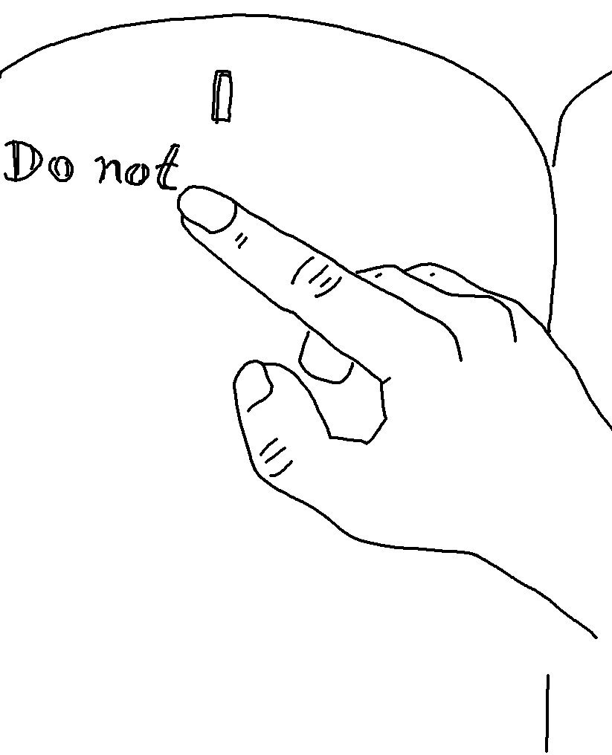
Love means _ _ _ _ _ what God has _ _ _ _ _ _ _ _ _ us.
2 John 6_{NLT}

